**About the Project**

This project is created by Global Rain for its client, Grazioso Salvare. The application will read data files provided and filter for potential dogs meeting the requirements to be trained as search-and-rescue dogs. This application is a full stack development which includes a database and web application dashboard. Code is open source and available on GitHub to be used by other organizations.

**Motivation**

Grazioso Salvare is looking to identify potential shelter dogs to be trained and used for search-and-rescue missions. Dogs that fall into an age criteria and breed type criteria excel at different types of missions. Certain breeds are known to have character traits for performing specified tasks such as mountain terrain, water rescue, wilderness, and scent work. This will help reduce the animal population within shelters as well as utilizing shelter animals for important rescue tasks in the Ausitn, Texas region.

**Application Functions**

This application will read database files using CRUD functions coded with Python. The user will be able to access a Dashboard for filtering though the given database of shelter animals to help search for potential Dogs to be trained. The Dash UI will filter dogs with predetermined specifications to include the best types of dogs for Water, Mountain, or Disaster Rescues and display interactive data for each selection. Below the table displays a pie chart of types of dogs meeting the specifications as well as a geolocation for the dog selected.

**Necessary Tools**

* MongoDB – A highly scalable document database with agile methodologies. MongoDB has drivers for all major programming languages and cuts out the need for configuring a database. It uses a flexible schema for storing data, storing records in BSON format which are retrieved in JSON format. MongoDB is equipped for handling high volumes and can scale vertically or horizontally.
* PyMongo – PyMongo is the official MongoDB driver for Python applications. It is useful for building query based applications with MongoDB.
* Python – Python is a popular in demand programming language. It is user friendly with extensive libraries known for its simplicity, readability, and versatility.
* Jupyter Notebook – A web-based IDE with Python capabilities.
* Dash – Dash framework is ideal for building python and HTML based visualization applications.

**Setting Up The Database**

* Use MongoDB to upload the file database. (sample file “aac_shelter_outcomes.csv”)
* Import data from database.

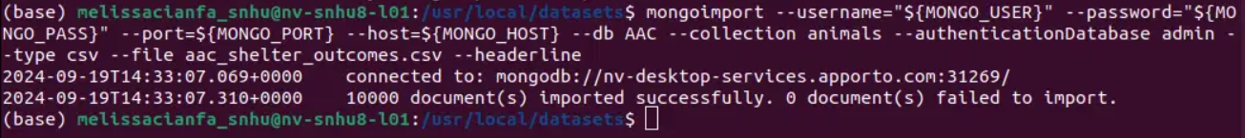

* Create a user with read/write permissions.

**Setting Up Python CRUD Functions To Be Used In Dash**

* **Create Method**

* **Read Method**

* **Update Method**

* **Delete Method**

**Tests**

Code to verify data is read and created.

**Using Jupyter Notebook**

* Import CRUD Python File.
* Import ProjectTwoDashboardDone.ipynb file.
* Run ProjectTwoDashboardDone.ipynb file in Jupyter.
* Open dashboard to search through database.

**Large Example of Dash UI**

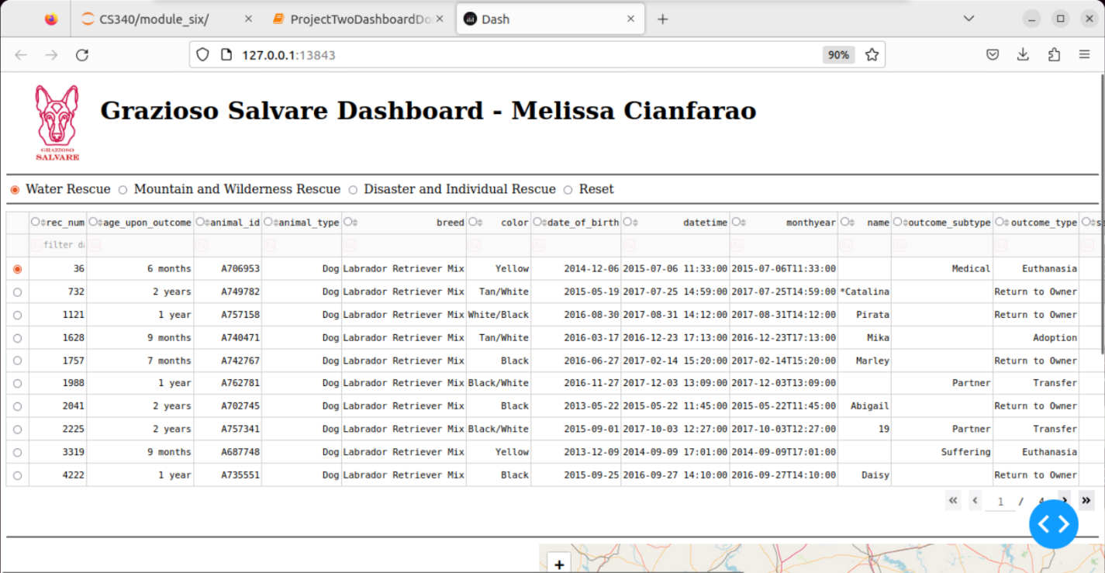

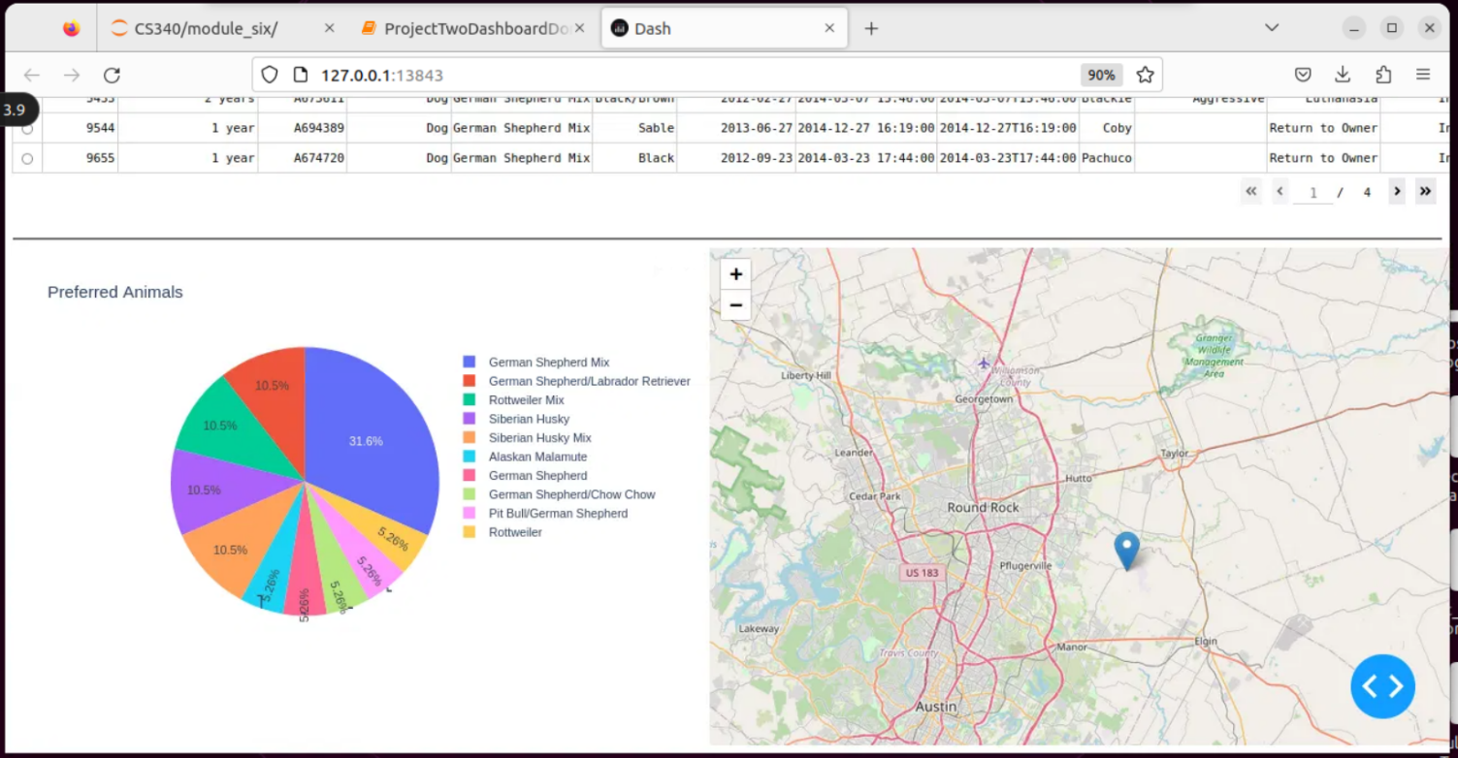

**Water Rescue Example**

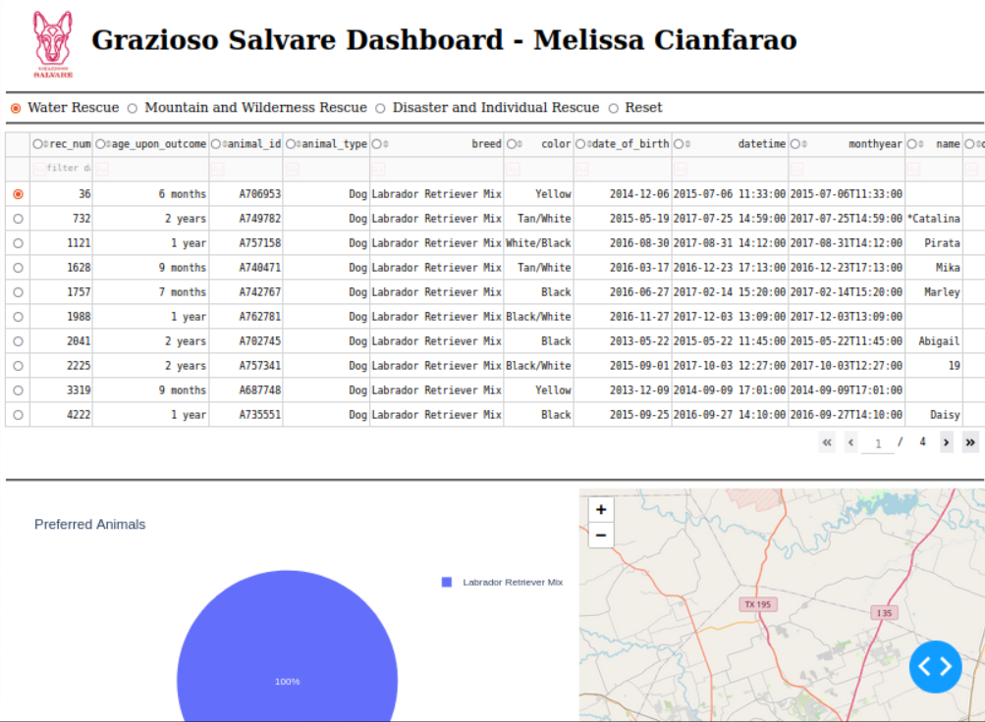

**Mountain and Wilderness Example**

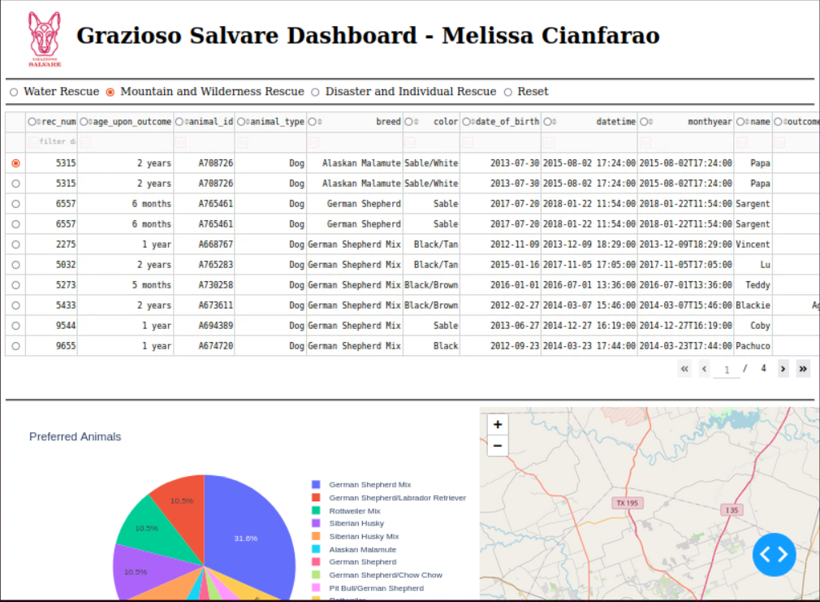

**Disaster and Individual Rescue Example**

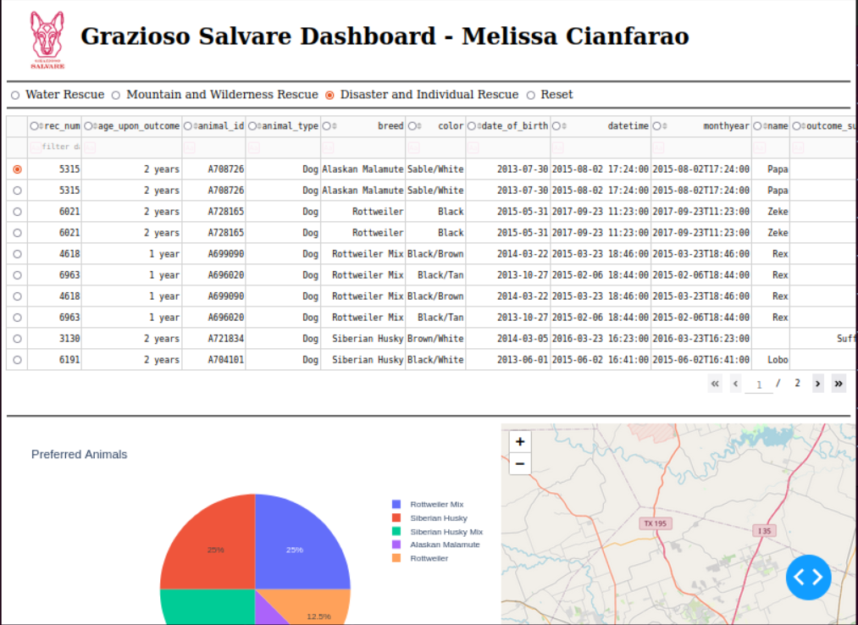

**Reset Settings Example**

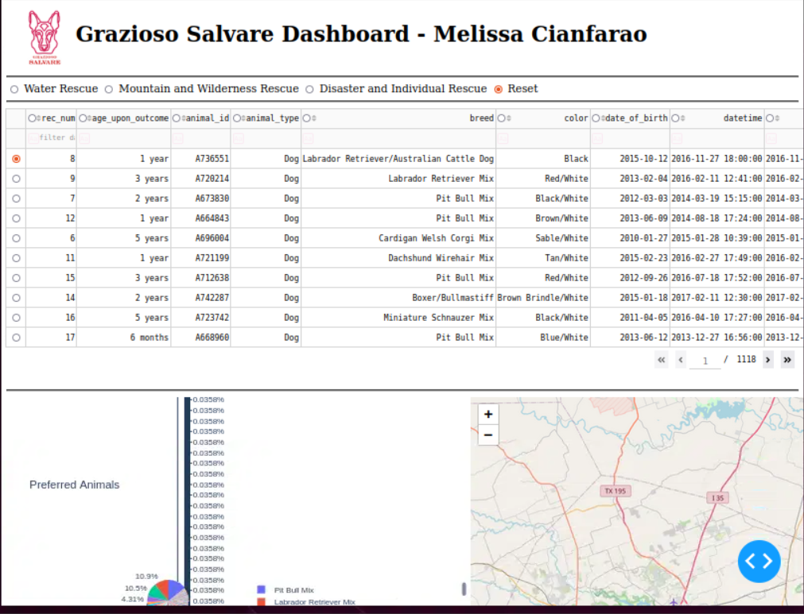

**Challenges**

While working on this project there were many challenges and difficulties to work through. Starting with setting up a user with read/write capabilities using database admin. Initially I set read/write up incorrectly and needed to create a new user with it set up to work. The next biggest challenge was setting up my __init__ method. I originally had it set to (self) but needed to include (self, username, password). Once this was included most challenges afterwards revolved around clean coding and fixing typos.

**Contact**

Melissa Cianfarano

**Resources:**

*Why Use MongoDB And When To Use It?* (2024). MongoDB. <https://www.mongodb.com/resources/products/fundamentals/why-use-mongodb?msockid=0b7d8672d7f461900b26941dd6096087>

*PyMongo Tutorial: MongoDB And Python*. (2024). MongoDB. <https://www.mongodb.com/resources/languages/pymongo-tutorial?msockid=0b7d8672d7f461900b26941dd6096087>

*12 Reasons Why You Should Learn Python (2023)*. (2019, September 23). GeeksforGeeks. https://www.geeksforgeeks.org/reasons-why-you-should-learn-python/

‌Python, R. (n.d.). *Develop Data Visualization Interfaces in Python With Dash – Real Python*. Realpython.com. https://realpython.com/python-dash/

**‌**

**‌**

**‌**